Puppet 6 Documentation

*Using Puppet 6 for Deploying Software on Windows Clients*

*April 9, 2019*

**Master Server (Centos7)**

*Preparation for Puppet installation*

1. Create a new CentOS7 virtual machine.
   1. Make sure to select “Software Selection” and choose “Infrastructure Server”. Find “System Administration Tools” and select it.
2. Set the Virtual Machine’s host name.
   1. Ex. Master.Puppet.io
3. Make sure that the virtual machine is properly connected to the Internet.
   1. Type “nmtui” to activate a connection if need be.
4. After the boot up process is finished, change /etc/hosts by typing “nano /etc/hosts”
   1. At the end of the line, add the IP address of the CentOS 7 server and adding the hostname right after it.
   2. After adding the server host and IP, add the IP address of the clients and their hostnames right after.

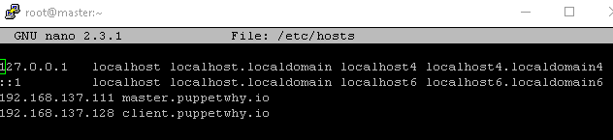

1. Once that is finished, make sure that you disabled SELinux by typing “nano /etc/sysconfig/selinux”.
   1. Change it to SELINUX=disabled.
   2. Save and exit.
2. The master and client needs to have the same time. You can do this for the CentOS 7 machine by typing “yum –y install ntp ntpdate”
   1. Then, “sudo ntpdate 0.centos.pool.ntp.org”
   2. You can type “date” to make sure that the time adjusted to the correct one.
3. After disabling SELINUX, make sure to add port 8140 by typing
   1. “firewall-cmd –add-port=8140/tcp –permanent”
   2. “firewall-cmd –reload”
4. To make sure that SElinux is disabled, reboot the system by typing
   1. “sudo shutdown –r now”

*Installation of PuppetServer*

1. To install puppetserver version 6, type
   1. “yum –y install <http://yum.puppetlabs.com/puppet6/puppet6-release-el-7.noarch.rpm>”
   2. “yum –y install puppetserver”
2. To make sure that right puppetserver version is installed, type “puppetserver –v”
3. Type “cd /etc/puppetlabs/puppet” and type “nano puppet.conf”
   1. Make sure to add [main] and [agent] configuration.
   2. Compare the screenshot below to your configuration. Note that your hostnames may differ.
4. 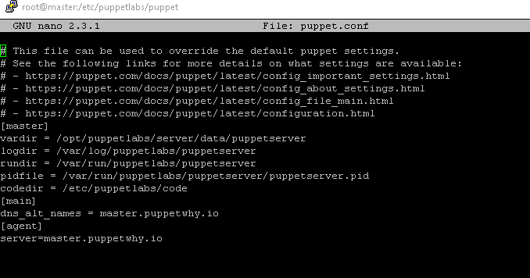Once that is done, save and exit.
5. Make sure that the puppetserver can run by doing “systemctl start puppetserver”
   1. There is a chance that puppetserver may fail to start. If this happens, increase the memory size of the virtual machine to 3072 if it isn’t already.
   2. If it keeps failing to start, type
      1. “nano /etc/sysconfig/puppetserver”
      2. Change the memory allocation by changing “JAVA_ARGS=”-Xms2g –Xmx2g” into “…Xms1g –Xmx1g”
      3. If that doesn’t work, change it to “…Xms512m –xxxXms512m”.
   3. Type “systemctl start puppetserver” and then “systemctl enable puppetserver”.

**Windows Client**

1. On your Windows client, go to <https://downloads.puppetlabs.com/windows/puppet6/>
2. Download the .msi package that is equal to or lower to the version your puppetserver is running. For example, if your puppetserver version is 6.4, download the 6.4 puppetagent or lower.
3. You will be greeted with the installation wizard. Go through the wizard and when it asks you for your puppet master, type the hostname or IP address of your puppet master.
4. Once the installation is finished, you will see a new option in your start menu. It will be called “Start Command Prompt with Puppet”. Click it.
5. Before you start, make sure that you change your /etc/hosts in Windows and that your client and master can ping with each other.
   1. On File Explorer, type this on the search bar “c:\Windows\System32\drivers\etc”
   2. Double click on “hosts” and edit it with notepad.
   3. Just like in the Puppet Master, add the IP of your server and client along with their hostnames right after them.
   4. Save and exit.
6. Next, go to “c:\ProgramData\PuppetLabs\puppet\etc” and double click on “puppet”. Open this with note pad and make sure that it has a configuration just like the screenshot below.

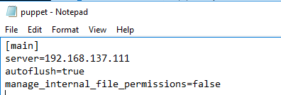

1. We will change the server from the IP to its actual hostname later. For some reason, there is a chance that this step can cause several issues so we will start the process through this.
2. Go back to the puppet command prompt and type “puppet –version” to make sure that the puppet agent downloaded successfully.
3. Type “puppet agent –t --debug --verbose”
   1. This may cause an error in the command prompt or it may not. If it does, try going back to the puppet config file and changing “server=192.168.137.111” into “server=[yourhostname]”.
      1. Ex. Server=master.puppet.io
   2. Try running “puppet agent -t --debug –verbose” once more and see if you still get an error. If you do, switch back to “server=192.168.137.111” or whatever your server IP is.
   3. Try running the same command again.

*Puppet Signing Certificate*

1. On your master server, type “puppetserver ca list --all” to check whether there was a request from your windows client.
   1. If it does, type “puppetserver ca sign --all” to sign the certificate request from your windows client.
2. Once that is done, go back to your Windows client.
3. Type “puppet agent –t –verbose –debug” again and make sure that there aren’t any errors.

*Deploying a Simple Text File*

1. With puppet, you can deploy certain configurations on your client machines. For this example and to make sure that puppet actually deploys properly to the clients, we will create a simple text file.
2. On Puppet Server, type “cd /etc/puppetlabs/code/environments/production/manifests”
3. Create a new manifest by typing “nano site.pp”
4. Inside, type a configuration that goes something like the screenshot below.

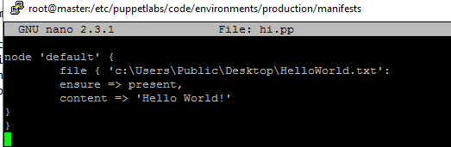

1. Save and exit.
2. On your Windows Client, type “puppet agent –t --verbose –debug.
   1. If there are not any errors, you should see the new text file that you created pop up on your Desktop.

*Deploying Software using Chocolatey*

1. Using Puppet and Chocolatey lets you install pre-packaged software that you can deploy to all of your clients. On your puppetserver, type “puppet module install puppetlabs-chocolatey --version 3.3.0”
2. After installing the module, type “cd /etc/puppetlabs/code/environments/production/manifests”
3. If you created a “site.pp” already, modify it by changing it to the screenshot below.

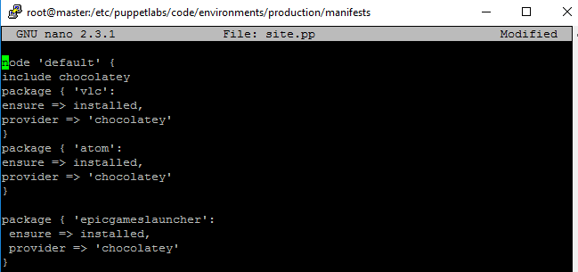

1. With chocolatey, you can install software packages by going to <https://chocolatey.org/packages>
   1. Just substitute the package { ‘[insert package here]’: to a software package in the site.
   2. Once you saved and exited, go to the windows client and type “puppet agent –t --debug --verbose”
2. All of the pre-package software that you stated in the manifest will be downloaded automatically.
   1. If for some reason the download hangs up, type “’Control’ + ‘C’” so that it continues running through the installation.